CS 437 LAB2 Yağız Gürdamar 22534

My Server IP Address: 159.89.28.38

Task 1:

Firstly I started with to clonening git repos to my server.

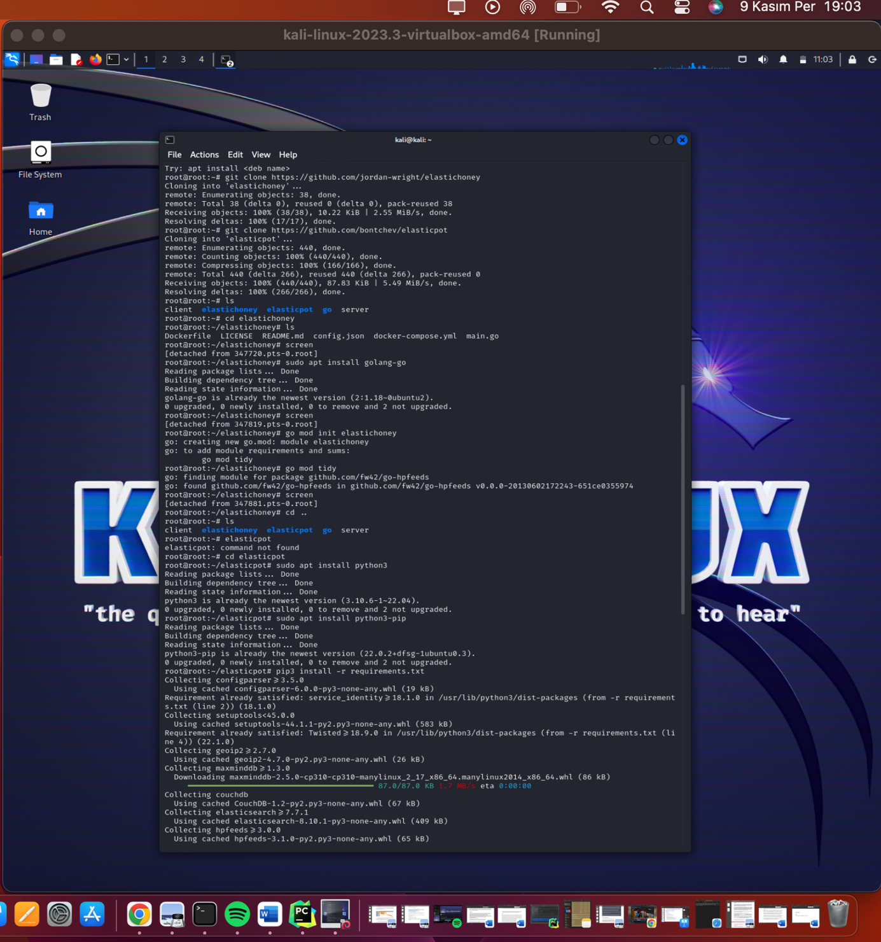

After clonening, I checked the repos from github and as I understood elastichoney is working with Go language. So I installed go to my server and did some configurations for go module. After that I started a ‘screen session and run the go module. And I started the queries:

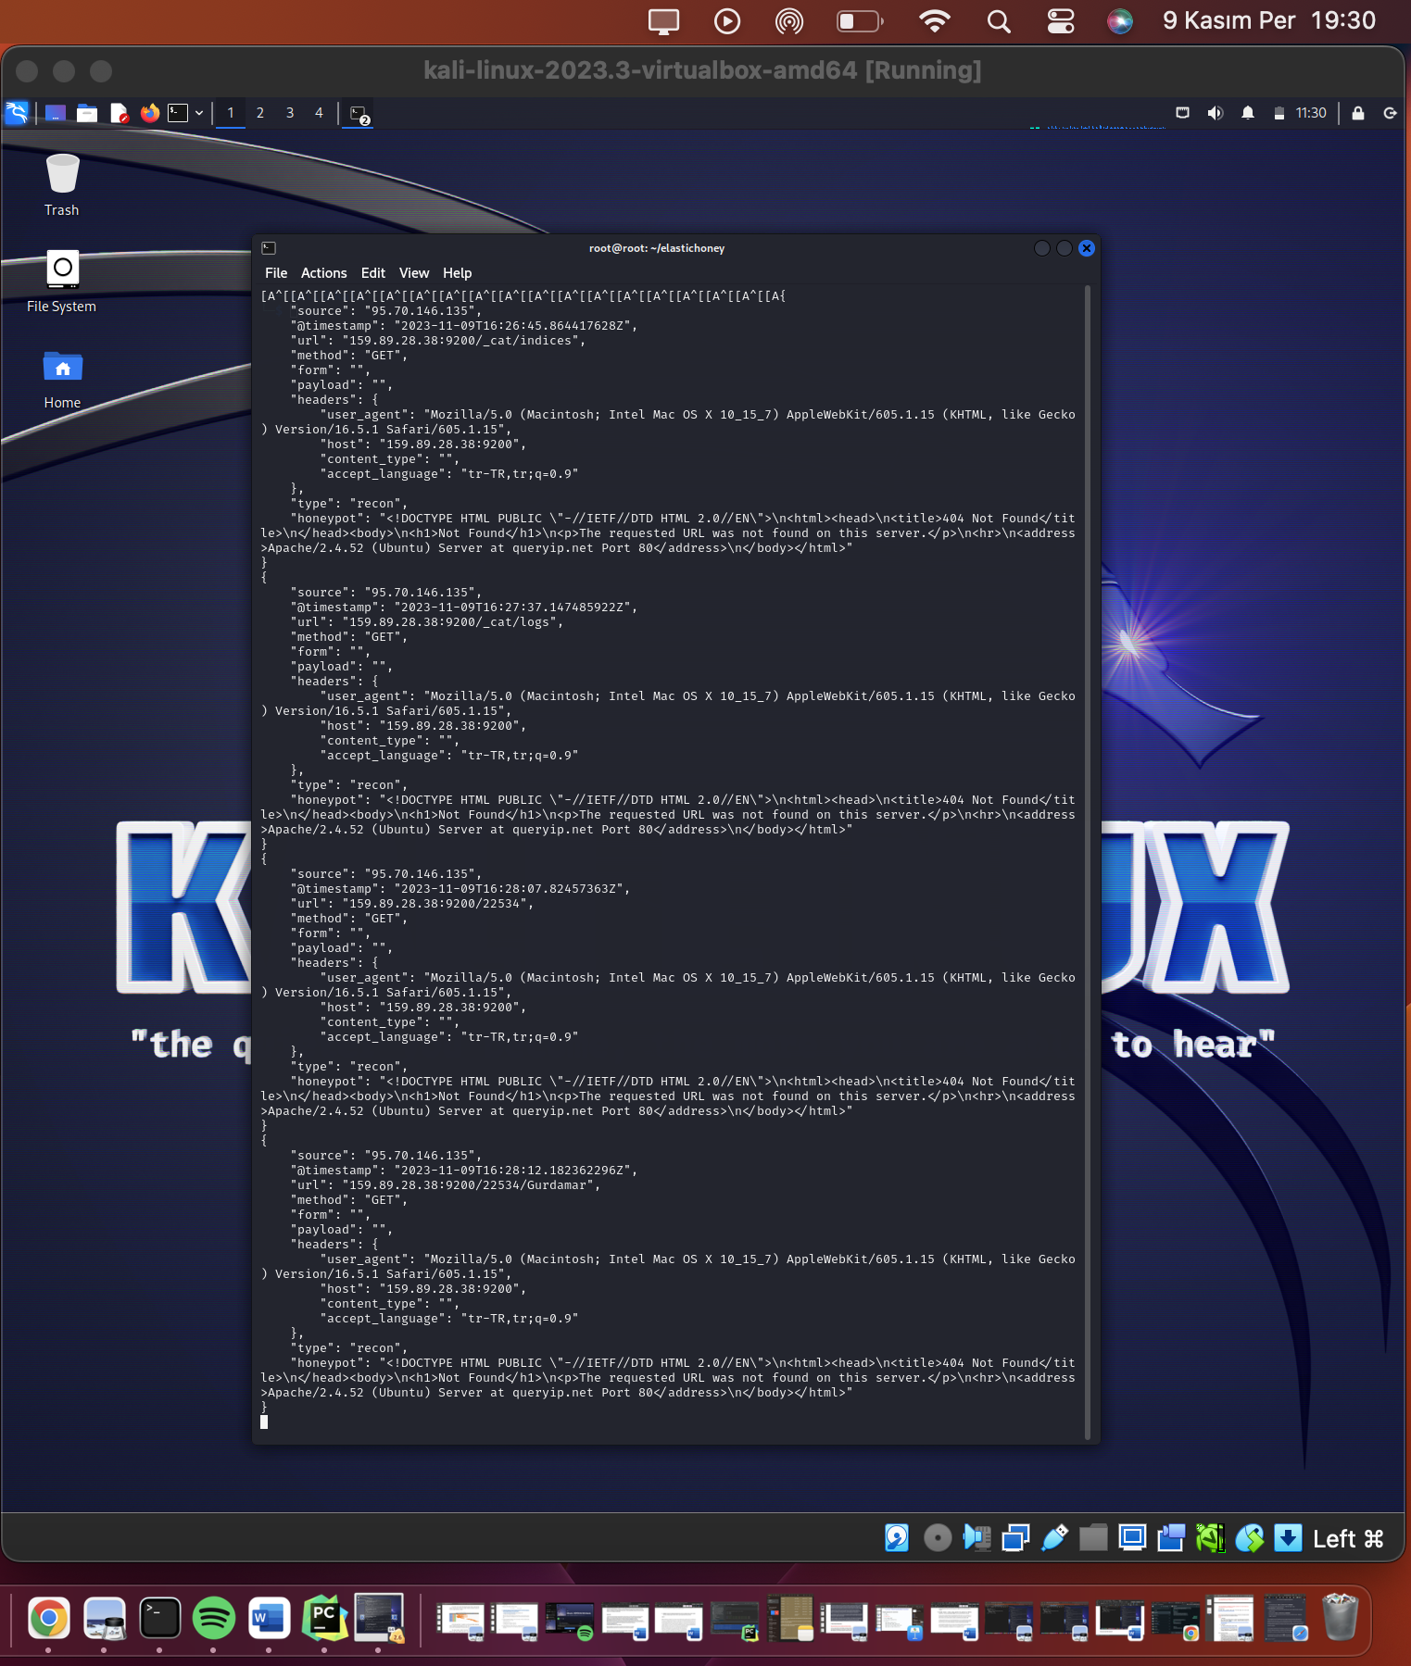

Here's a breakdown of what each log entry indicates:

1. **Access Attempt to `/_cat/indices`**:

- **Source IP**: `95.70.146.135` has tried to access the list of indices in an Elasticsearch instance.

- **Timestamp**: The access attempt occurred on `2023-11-09T16:26:45.864417628Z`.

- **URL**: The target was `159.89.28.38:9200/_cat/indices`.

- **User Agent**: The request was made using a browser identified as Safari on macOS 10.15.7.

- **Result**: The honeypot responded with a fake `404 Not Found` error page, simulating an Apache server response.

2. **Access Attempt to `/_cat/logs`**:

- Similar to the first entry, but the URL attempted was `159.89.28.38:9200/_cat/logs`.

- The timestamp was `2023-11-09T16:27:37.147485922Z`.

- The honeypot again responded with a `404 Not Found` page.

3. **Access Attempt to `/22534/Gurdamar`**:

- This attempt tried to access a more specific path, which might indicate a targeted probe or scan.

- It occurred at `2023-11-09T16:28:12.182362296Z`.

- The same user agent was used, and the honeypot provided the same `404 Not Found` response.

The consistent source IP address and user agent string across these attempts may suggest that the same actor or bot is making these requests. The purpose of these requests could be reconnaissance (as indicated by the "type": "recon"), trying to discover if an Elasticsearch instance is running on my server, potentially looking for unsecured clusters to exploit.

The honeypot responses are simulating an Apache server's 404 error pages, which is a method to deceive scanners or attackers into believing that there is no valuable information or service running on the port they are probing.

After that I started to build Elasticpot.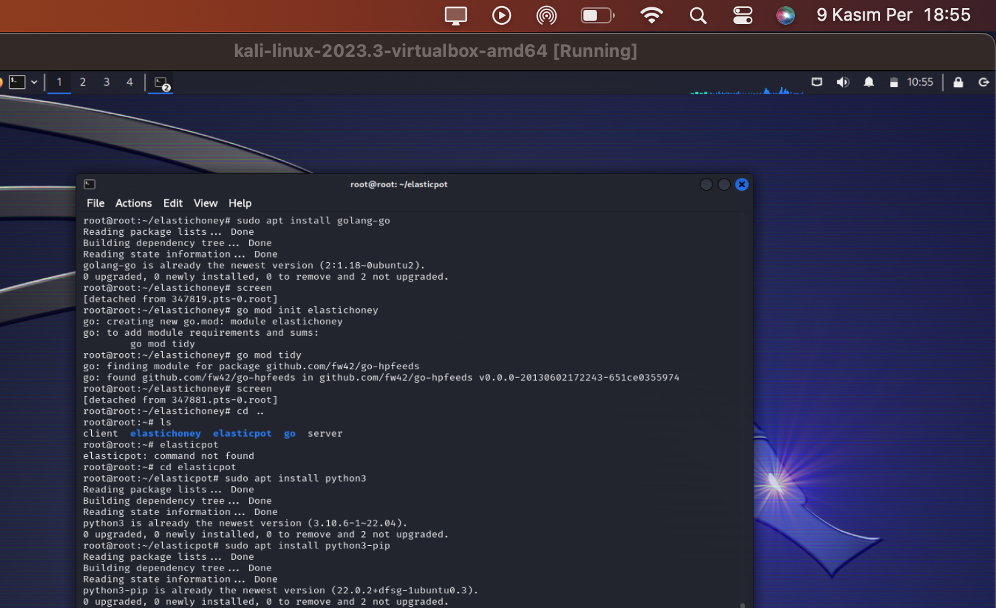

I installed python for elasticpot.py. However elasticpots default port is 9200 so I searched config file and changed the default value to 9300: 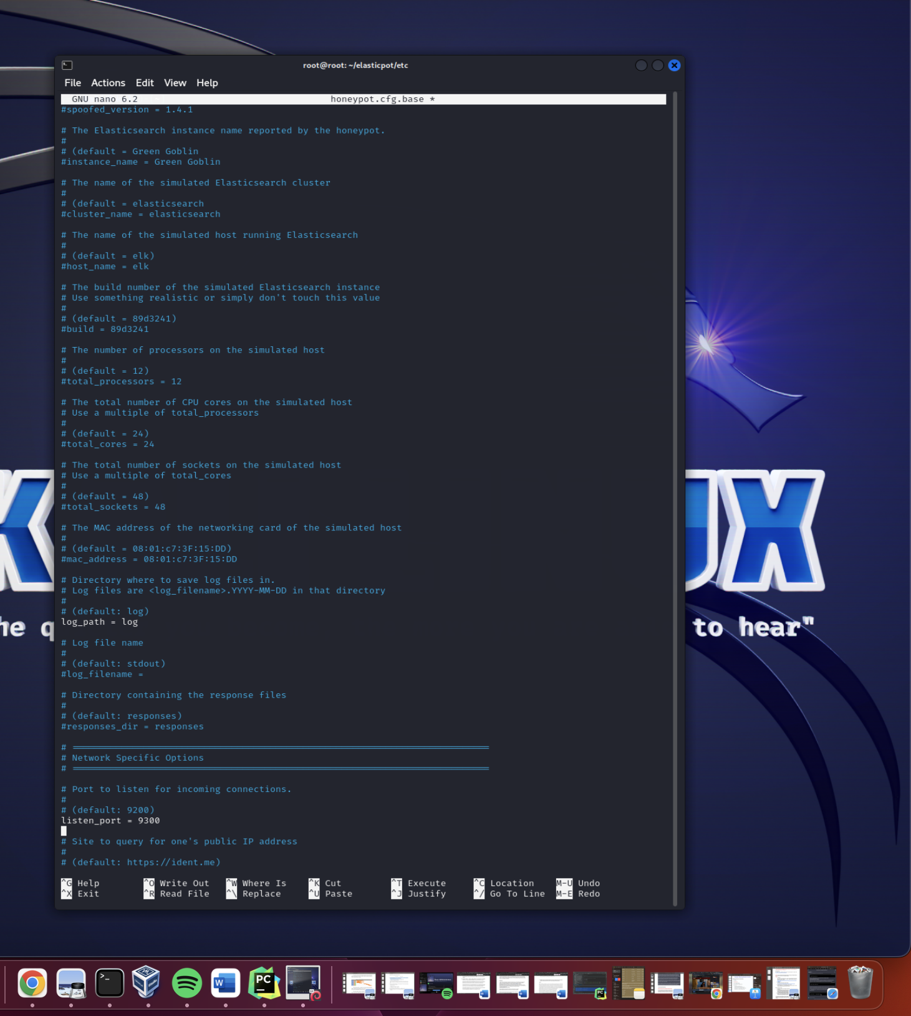

The listen_port = 9300.

I after that I basically started the screen session and you can find my results.

For /_cat/indices: 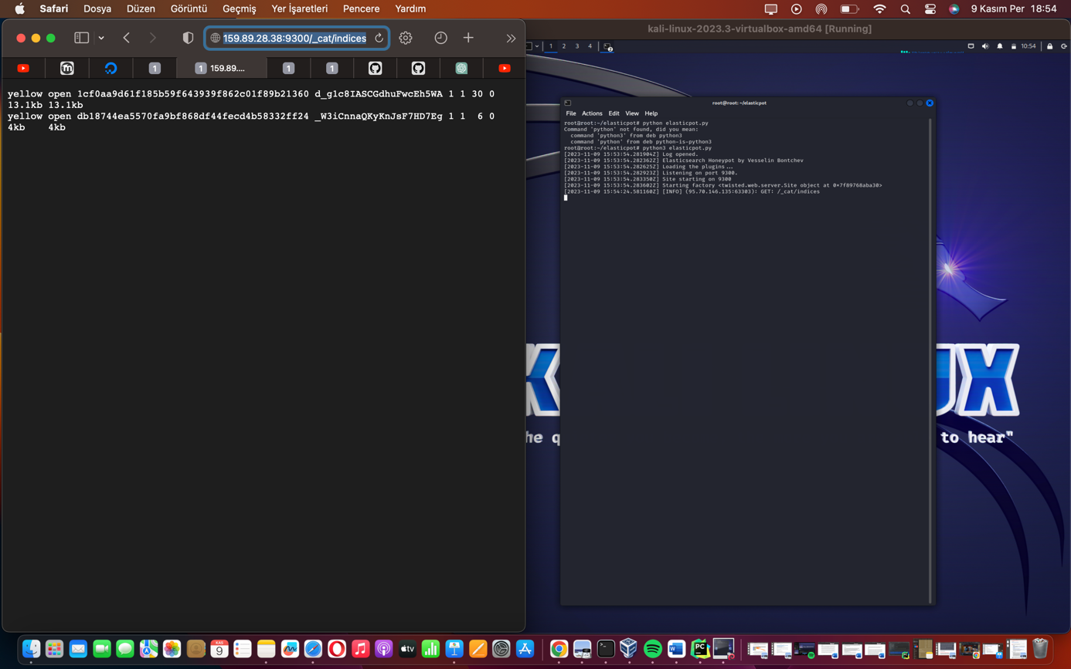

- Web Page Output: It shows two indices with a "yellow" health status, which typically means that the index has been created and is open, but replicas are not allocated (this can happen in a single-node cluster). The details include the index names (which seem to be hashes), the number of primary shards (`1`), the number of replica shards (`1`), the number of documents (`30` and `6`, respectively), and the size of the indices.

- Debian Server Log: The server log indicates that a GET request was made to the `/_cat/indices` endpoint from the source IP `95.70.146.135` at the given timestamp. The log is a simple informational message that records the access attempt.

For /_cat/logs: 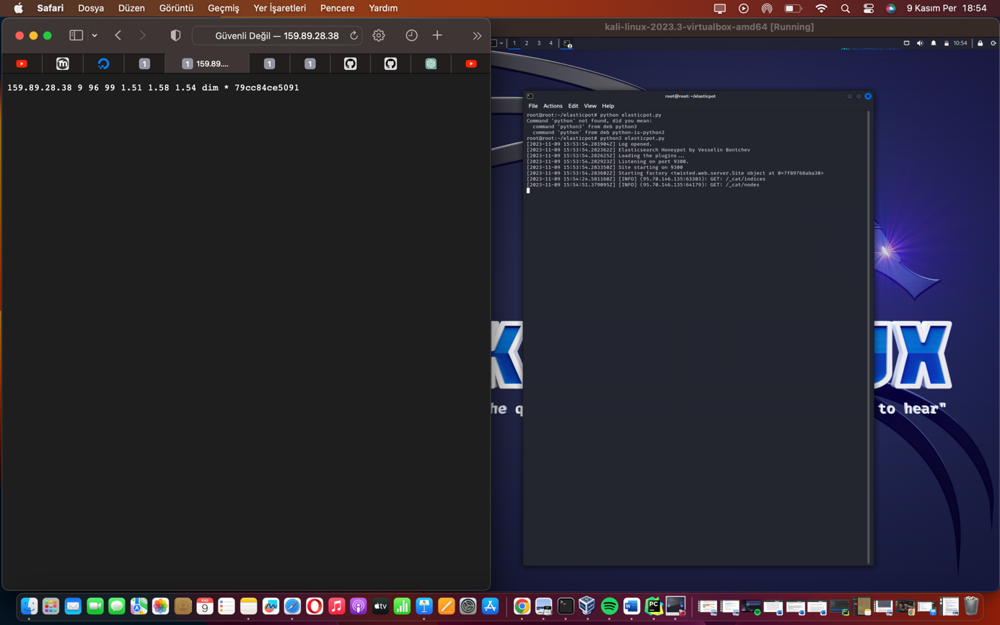

- This output seems to be truncated or not formatted correctly, but it appears to show some sort of log data with several metrics that could be related to Elasticsearch's performance or document stats. The values may represent document counts, shard information, or other metrics, and `dim *` could be a reference to the default setting for a field data type.

For /22534/Gurdamar:

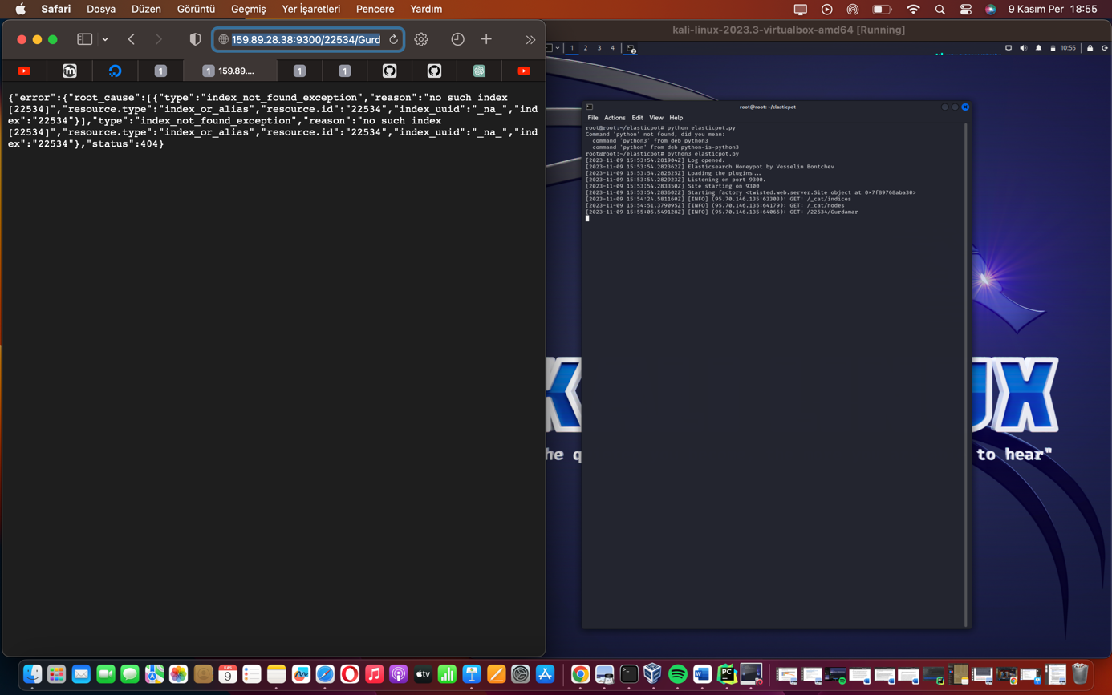

- The response is a JSON formatted error message indicating that the index named `22534` does not exist on the server ("index not found exception"). This is a typical Elasticsearch response when you try to access an index that hasn't been created.

Overall, the logs and the web page outputs are consistent with what I would expect from an Elasticsearch instance responding to queries. ElasticPot appears to be effectively simulating Elasticsearch behavior, providing realistic but fake responses to the queries it receives. This can be useful for identifying and logging potential scanning activity without exposing an actual Elasticsearch instance to the internet.

Furthermore I checked the log files of elastichoney and I used grep command the results which I found:



The log entries you've provided from the `elastichoney` honeypot indicate that it has captured several GET requests to the `/_cat/indices` URL. Each entry in the log provides a JSON object with several fields, which detail the nature of the request and the response provided by the honeypot. Here's a breakdown of the key components in the log entries:

1. source: This field indicates the IP address of the source of the request.

2. @timestamp: The exact time when the request was made.

3. url: The URL that was accessed; in this case, it's the `/_cat/indices` endpoint, which is used to list indices in Elasticsearch.

4. method: The HTTP method used, which is GET.

5. headers: A collection of HTTP headers that were sent with the request, such as `user_agent` and `host`.

6. type: This is likely indicating the type of activity detected, labeled as "recon" for reconnaissance.

7. honeypot: The response returned by the honeypot, which in this case is a 404 Not Found HTML page, mimicking an Apache server error response.

To analyze this data further and to use it in a report, we can perform several actions:

- Log Format: The logs are in JSON format, which is excellent for automated processing, but we might want to include more human-readable log entries or summaries for easier manual review.

- Additional Data: We could enhance the honeypot to log additional data, such as the full request URI, the body of POST requests, or any parameters that are passed.

- Alerts and Notifications: Implementing real-time alerts for certain types of requests or patterns of activity could help in promptly identifying potential threats.

I could not gather log output from elasticpot, I have tried to change on config file but still I could not manage.